**Objectives**

* Identify the applications and benefits of Bootstrap
  + Responsive Web Design (RWD), Disadvantages of sites without RWD, Mobile First design, Bootstrap 4, emulate devices in Chrome Browser
* Demonstrate Bootstrap usage with starter template
  + doctype, viewport meta tag and attributes, Bootstrap CDN
* Demonstrate RWD using Grid System
  + Grid System, 12 columns, devices and corresponding prefix of bootstrap class, container, container-fluid, row, col
* Demonstrate creation of navigation bar
  + navbar, navbar-expand-lg, navbar-dark, bg-dark, navbar-brand

**Responsive Web Design and Device Emulation**

Observe differences between a page with RWD and a page without RWD

**Site without RWD**

1. Open <http://cbseacademic.nic.in/> on the browser in your mobile phone
2. Observe the following in the web page:
3. Is the menu visible?
4. If an item in the top menu needs to be selected, what needs to be done?
5. What are the difficulties faced when viewing this site in mobile?

**Site with RWD**

1. Open [https://code.cognizant.com](https://code.cognizant.com/) on the browser in your mobile phone
2. Find out how easier is it to understand and navigate through the pages

**Device Emulation**

When developing a web page it is impossible to check device compliance by testing it in the actual device. To overcome this difficulty Chrome Browser provides tools to emulate the view on various devices. Follow the steps below to emulate a specific web page in various devices:

1. Open [https://code.cognizant.com](https://code.cognizant.com/) on Chrome browser
2. Open menu in the browser
3. Select More Tools > Developer Tools
4. Click the “Toggle device toolbar” option

https://cognizant.e-box.co.in/uploads/Image/OBL/BTS1.JPG

1. In the top using the first drop down select the device. The browser window will change the width according to the device selected.

**Getting Started with Bootstrap**

Create a web page displaying Hello World using the Bootstrap Starter Template.

https://getbootstrap.com/docs/4.3/getting-started/introduction/

**Login Page Layout for hTrack Application**

Health tracking application hTrack requires a login web page similar to the one provided below. The left hand side of the application displays the features and benefits of the online application. Right hand side of the web page displays login form. For the sake of simplicity, the login form details are not included. This login page if displayed in a mobile device should look like the sample image given in the bottom.

**Desktop**

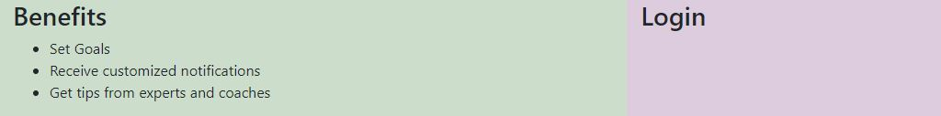

**Mobile**

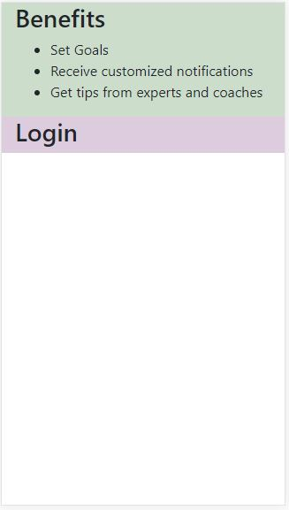

**Navigation Bar for hTrack**

Include navigation bar for hTrack login page. Refer screen shots below:

**Desktop**  
  
